Wireless Scanner Guide:

KB0010127  -  [Latest Version](javascript:void(0))

***Pairing Wireless Scanners***

***Issue:***  
***Generally, Tablet systems use wireless scan guns instead of the wired scanner found on Register one. This guide will cover how to pair a handheld scanner with a Tablet system.***  
  
***Resolution:***  
***Atl+Tab to Xenvironment and hit F3*** F,{25c64fd0-82de-424c-b887-7abb6a0c1f3f}{169},3.125,3.125

F,{25c64fd0-82de-424c-b887-7abb6a0c1f3f}{177},3.125,3.125

Click on option 15 **Bluetooth Scanner Config** and click **Continue**

F,{25c64fd0-82de-424c-b887-7abb6a0c1f3f}{199},3.125,3.125

Click Yes when asked to launch the Bluetooth scanner pairing assistant.

F,{25c64fd0-82de-424c-b887-7abb6a0c1f3f}{221},3.125,3.125

Click on Prep Scanner For Pairing

F,{25c64fd0-82de-424c-b887-7abb6a0c1f3f}{243},3.125,3.125

Click on the first box on the left and scan the box

F,{2a80cbb0-e89b-4818-8fa6-8e09ca1a844f}{10},3.125,3.125

Click on the middle box and scan it

F,{2a80cbb0-e89b-4818-8fa6-8e09ca1a844f}{32},3.125,3.125

Click on the last box and scan it, then clock the Close button

F,{2a80cbb0-e89b-4818-8fa6-8e09ca1a844f}{54},3.125,3.125

The pairing tool should start to scan for Bluetooth devices and if all barcodes were scanned successfully, then the scanner should show up under New Bluetooth Scanners.

Once it’s done scanning click on the device under New Bluetooth Scanners and then click on **Connect Selected Scanner**

(The device should show up as Xenon 1902 and show its serial number.)

After clicking Connect Selected Scanner, the **Scan Code Form** box should pop up.

F,{2a80cbb0-e89b-4818-8fa6-8e09ca1a844f}{97},3.125,3.125

Click on the first box (at the top) and scan the Barcode that appears.

F,{2a80cbb0-e89b-4818-8fa6-8e09ca1a844f}{119},3.125,3.125

Click on the second box and scan the Barcode that appears,

.

F,{2a80cbb0-e89b-4818-8fa6-8e09ca1a844f}{141},3.125,3.125

Click on the third box and scan the Barcode that appears.

If pairing was successful you will get a "Pairing success!" message.

Click ok on the message:  
  
F,{2a80cbb0-e89b-4818-8fa6-8e09ca1a844f}{163},3.125,3.125

(If you get a Pairing failed! message, then you must start the pairing process over from the beginning.)

F,{2a80cbb0-e89b-4818-8fa6-8e09ca1a844f}{185},3.125,3.125

Scan the bar code the shows up in the Programming Form and click on the message “Click when done scanning”

F,{2a80cbb0-e89b-4818-8fa6-8e09ca1a844f}{207},3.125,3.125

Scan the barcode on the Scan Test Form pop up.

The box under the barcode should populate after scanning.

F,{2a80cbb0-e89b-4818-8fa6-8e09ca1a844f}{236},3.125,3.125

If successful you will receive a Success message.

F,{2a80cbb0-e89b-4818-8fa6-8e09ca1a844f}{251},3.125,3.125

The scanner should show under the Paired Bluetooth Scanners field once successfully paired with the Tablet.   
  
Once the Scanner is paired, close the pairing tool and start Xstore as normal.

**Scanner Configurations -**

Pair the scanner to the base. Scanning the barcode on the bottom/back of the base and placing the scanner in the base for 15 – 20 seconds should accomplish this. You should hear a few beeps during this process.

* Un-pair the scanner from the docking station with the below code

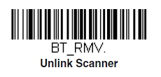

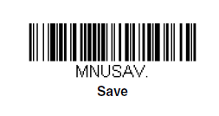

**If scanner isn't linked to base / Not Charging:**

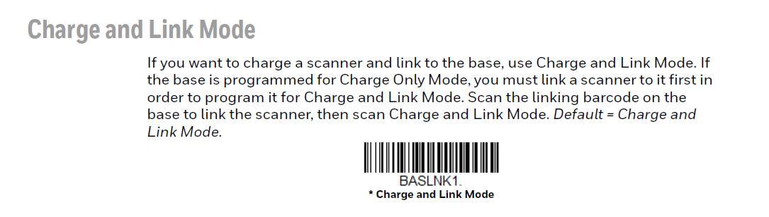

**Replacing Scanner that is broken or Linked to a Base:**  
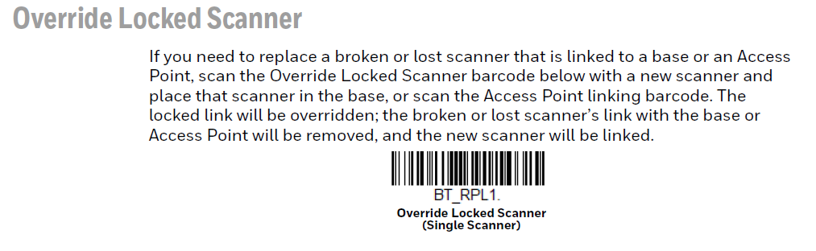

**Pairing Scanner to New Base for the First time after Factory default/ Brand new Scanner:**

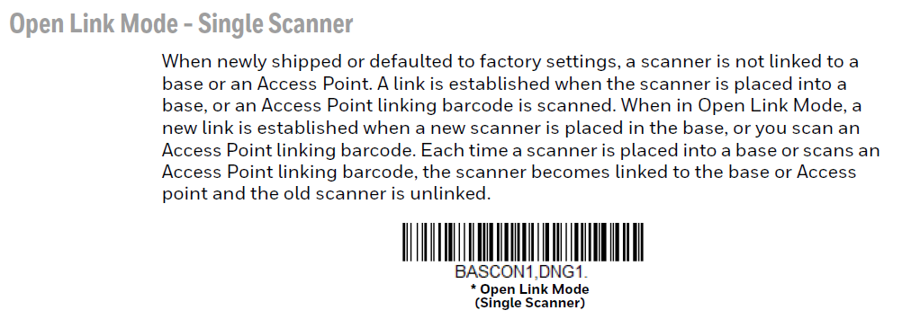

**Hot Fix for scanner to added enter and leading/trailing characters :**

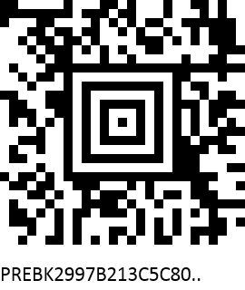

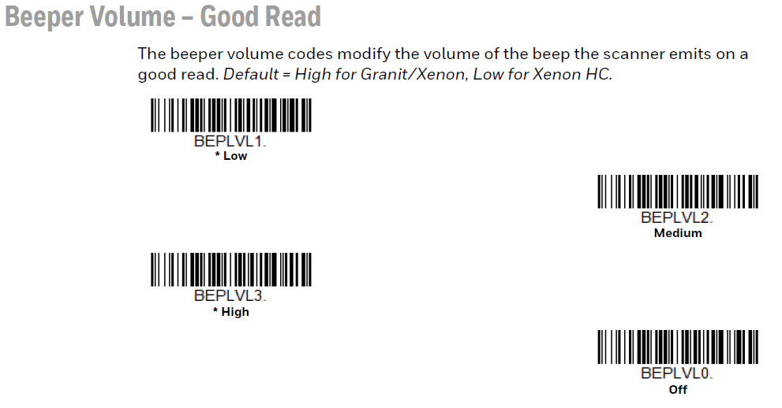

**\*IF THE SCAN GUN HAS LIGHT ON BUT DOES NOT READ BAR CODE\***

1. open up HIBBNET in Internal Apps
2. Open up HOT FIX_XSTORE Scanner not scanning warehouse bar codes
3. Scan large bar code at bottom of article
4. Scan gun should then be able to scan bar codes
5. This will work for both register 1 and register 2 scan guns.